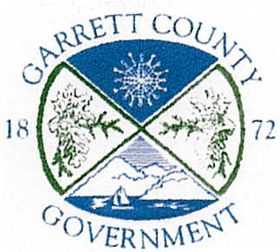
GARRETT COUNTY BOARD OF ELECTIONS
2008 Maryland Hwy Suite #1
Mt. Lake Park, Maryland 21550
(301) 334-6985
Fax (301) 334-6988

AGENDA

Tuesday May 4, 2017

5:00 P.M. Monthly Board Meeting

@ Office Conference Room

- Call Meeting to Order and Determine Quorum
- Approval of April 4, 2017 Minutes

- Director Report

- Old Business

- New Business & Correspondence

- Next Meeting Announcement
- Adjournment

